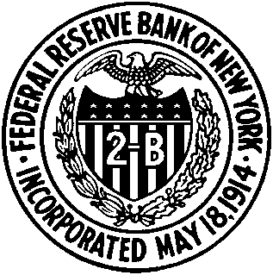

REGISTRATION FORM

Financial Globalization: Causes and Consequences

December 2-3, 2004

Federal Reserve Bank of New York

33 Liberty Street, New York, NY 10045
12th Floor Conference Center

Name: ___________________________________________________________
Title/Affiliation: ___________________________________________________________
Address: ___________________________________________________________
E-mail/Phone/Fax: ___________________________________________________________

Which events will you attend?

I will attend conference on Dec. 2, 2004 at 9:00* a.m. – 5:15 p.m. Yes No

I will attend conference on Dec. 3, 2004 at 9:00 a.m. – 12:45 p.m. Yes No

*Continental breakfast/registration will begin at 8:30 a.m.
____________________________________________________________________________

Hotel Information
Wall Street District Holiday Inn Marriott Financial
15 Gold Street 85 West Street
New York, NY 10038 New York, NY 10006
Tel: 212-232-7700 Tel: 212-385-4900
Fax: 212-425-0330 Fax: 212-227-8136

Club Quarters Downtown Crown Plaza Times Square
52 William Street 1605 Broadway at 49th Street
New York, NY 10005 New York, NY 10019
Tel: 212-269-6400 Tel: 212-977-4000
Fax: 212-269-6464 Fax: 212-333-7393

For your information, presenters/discussants will be staying at the Club Quarters Downtown, located at 52 William Street, NYC.

Please return the completed form to Linda Cimini by November 1.
Fax: 212.720.8363
Email: RMAG.Conference@ny.frb.org

