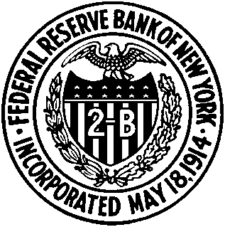

REGISTRATION FORM

New York Area Workshop on Monetary Policy

November 20, 2009

Federal Reserve Bank of New York

33 Liberty Street, New York, NY 10045
13th floor, Board Room

Name: __________________________________________________________

Affiliation: ___________________________________________________________

Address: ___________________________________________________________

E-mail/Phone/Fax: ___________________________________________________________

Please return the completed form to Betsy Turner by November 13.
Email: betsy.turner@ny.frb.org

